***CIS 3120, Section ETRA***

***Prof Nanda Kumar***

***Group Project Presentation***

***December 20, 2016***

**Stock Parameters Extraction, Analysis, Display and Ranking System**

**(SPEADARS)**

***Group Members***

**Justin Pangilinan**

**Nikola Ognjanovic**

**Shobhit Ratan**

**Stock Parameters Extraction, Analysis, Display and Ranking System**

**(SPEADARS)**

We used Python concepts learnt in the class to develop a data analytics system, which extracts stock data from yahoo finance website and provides information about user defined parameters. Salient statistical analysis and Python concepts used for the package are - Pandas, factor plot using Seaborn, matplotlib.pyplot, , dataframe, import, requests, numpy, conditional statements (if, elif, else), for and while loops, python dictionary etc.

**Program Execution Steps**

1. Run the file speaderspangilinanognjanovicratan.ipynb in Jupiter software

2. Input Stock tickers for the stocks on which we want to run Analytics and enter the desired price (open, high, low, close, Adj close) or volume :

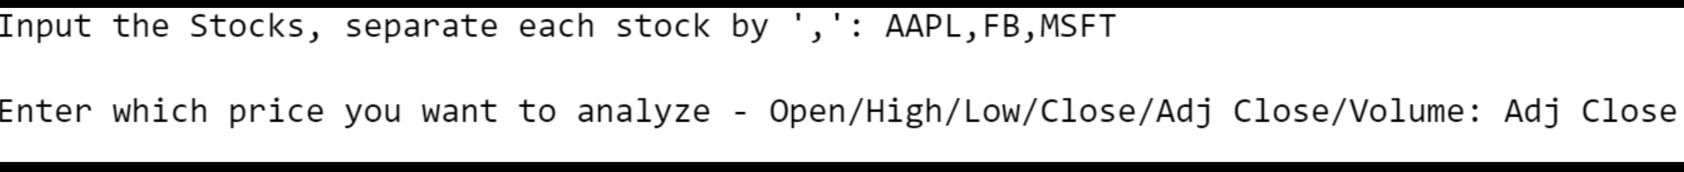

***Open*** *– Stock Price at the opening bell,* ***High*** *– Highest price during the day,* ***Low*** *– Lowest price during the day,* ***Close*** *= Unadjusted closing price of the day,* ***Adj Close*** *- Adjusted closing price of the day, Volume – How much stock volume was traded during the day*

3. Based on the inputs, the SPEADARS extracts the stock price data from [www.finance.yahoo.com](http://www.finance.yahoo.com) and provides following data / analytics for the selected stocks :

**a) Displays last five days Adjusted Closing Price and Stores extracted data in a Python Dictionary.**

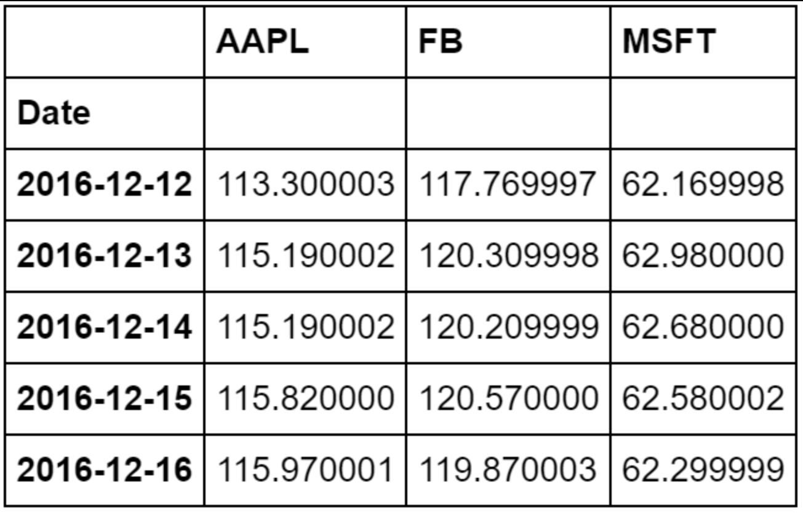

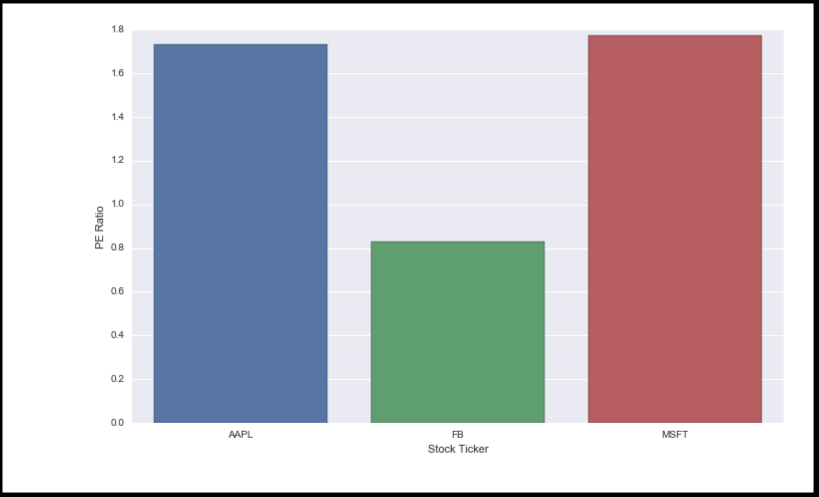

**b) Summarizes technical data viz P/E ratio, % Price Change, Short Ratio and time.**

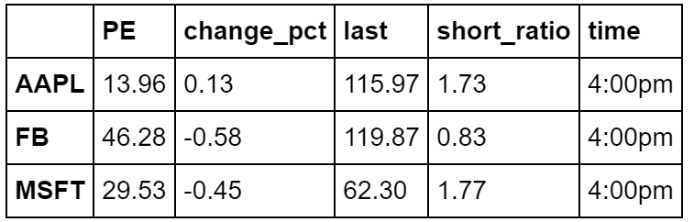

**c) Calculates EPS and stores it in Python Dictionary**

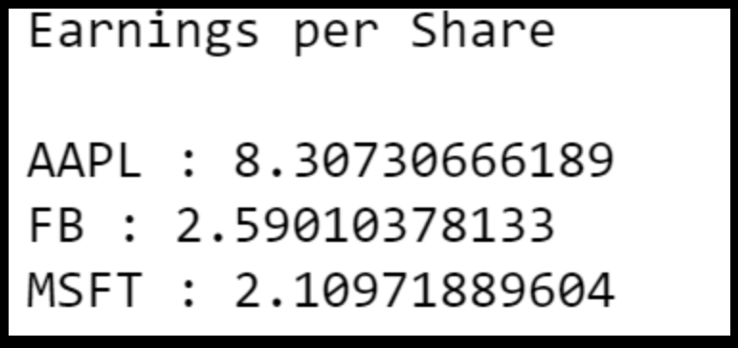

**d) Displays line graph representing Historical stock price movement over the last one year.**

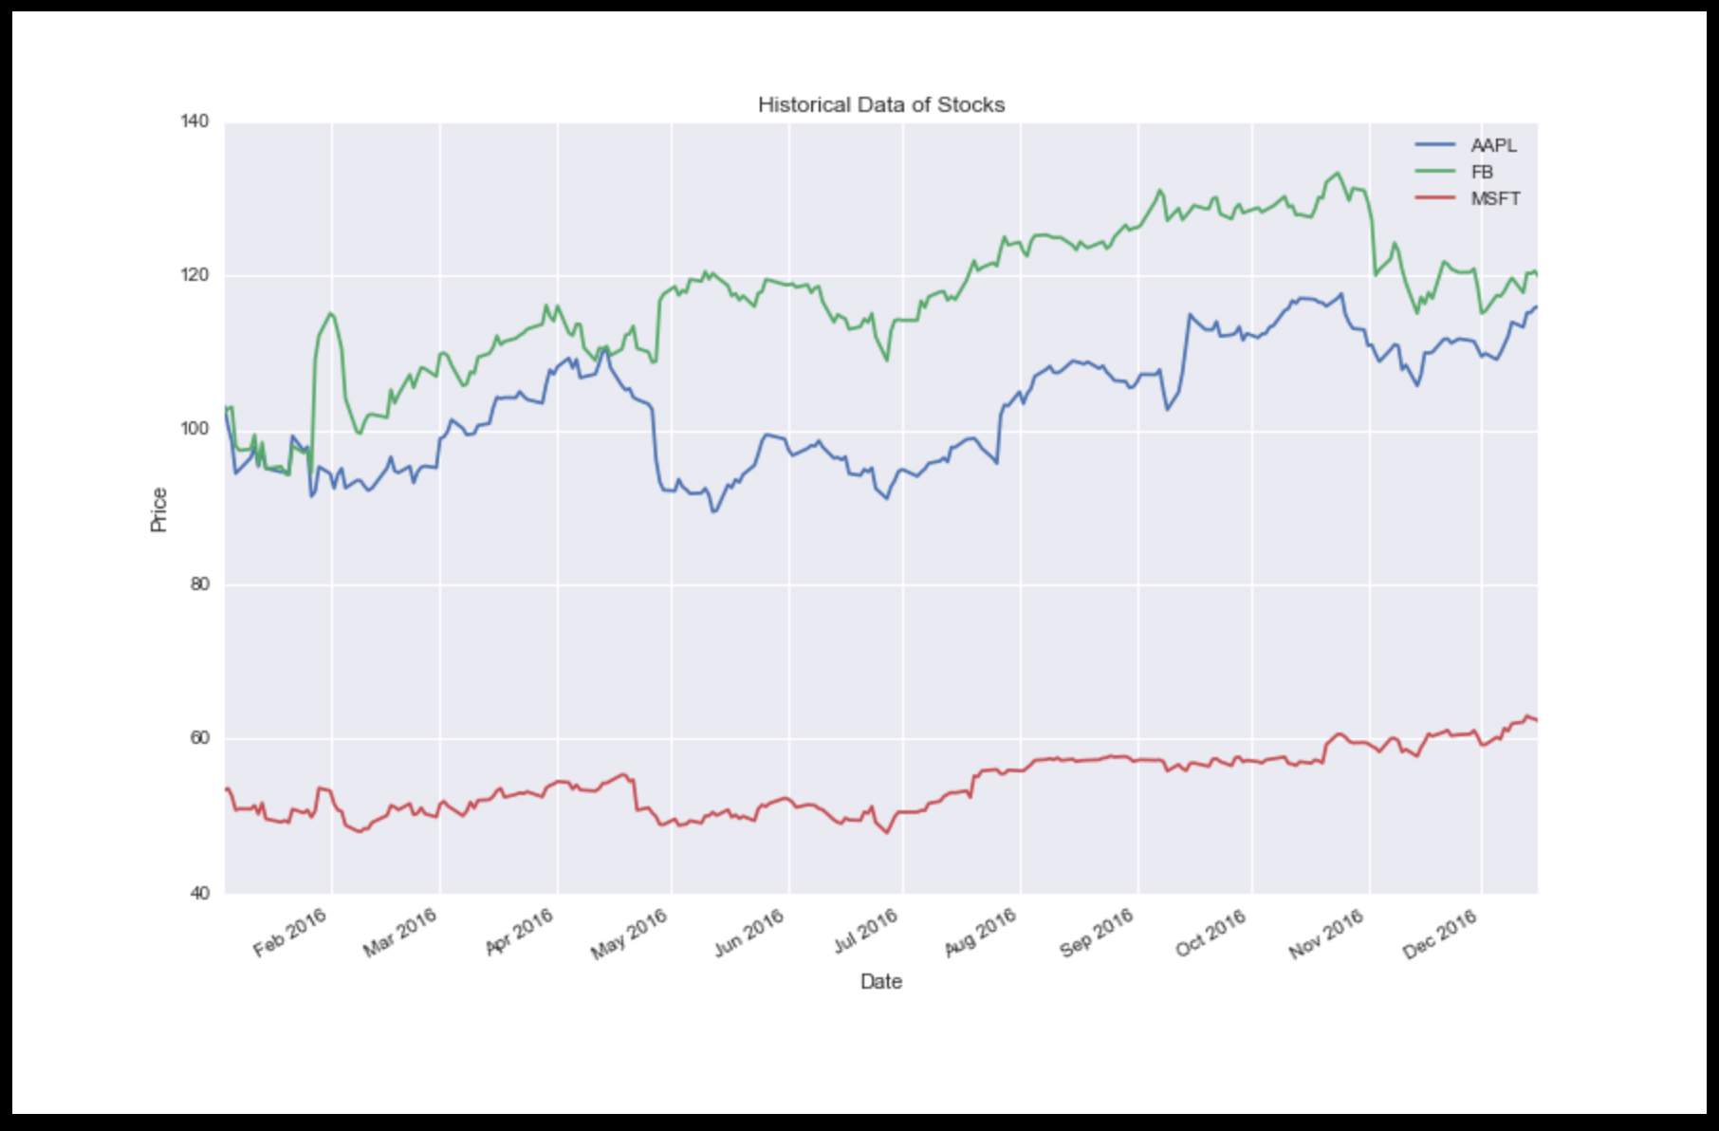

**e) Input desired parameter to rank the stocks. The system ranks and displays stocks based on user selected technical parameter. Data is arranged in Python dictionary.**

